Making Monsters Using Line, Shape, Color, Pattern and Texture

Summary: Students were asked to create a unique monster with one magical power that could be communicated visually.

Objective:
- Students were able to learn and understand organic and geometric shapes.
- Students were able to describe where in their piece they communicated visually their monsters magical power.
- Students were able to demonstrate smooth coloring method
- Students were able to demonstrate the use of line and shape in a pattern
- Students were able to communicate texture through their use of patterns to show a certain texture on their monster.

Grade Level: Kindergarten – 2nd grade

Teacher example:
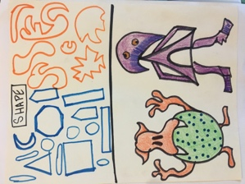

Steps of the project:

- Students were given one piece of paper to draw one large sketch of their monster in pencil starting with the large shapes.
- Students filled in the large spaces on their sketch with colored pencils, markers, and crayons
- Students used black sharpie to create the small details onto of their monster.

Class discussion and concluding thoughts during art critique:
Students presented their work by sharing where in their picture they had created a visual representation of a magical power for their monster. The project gave students an opportunity to use their imagination through their understanding of the elements of art.

